Amaan Mustafa
Dr. Riley
CS 2003
10 March 2026
CS-2003 Project 1 Report

Overview
The purpose of this project is to test all five sorting algorithms in Java by analyzing each algorithm’s algorithmic efficiency. This project capitalizes on the sorting algorithms such as quick sort that I learned in class, and it combines this knowledge with the quantitative methods and skills required to analyze algorithmic efficiency such as Big O notation. After implementing the entire coding for each algorithm, I must implement a process that benchmarks each algorithm to get a better picture of algorithmic efficiency that I can use to create a graph that uses data to illustrate each algorithm’s performance. There are two methods to benchmark each sorting algorithm: significant operation calculation and summation and using the Java Microbenchmarking Harness (JMH). Calculating each algorithm’s significant operation allows the programmer to measure the efficiency and performance for each algorithm’s critical operations; in contrast, the Java Microbenchmarking Harness adapts to Java’s time usage, whether it involves garbage collection or other object-oriented duties, to ensure consistent results for each algorithm’s benchmark.

Methods
After developing each sorting algorithm’s code, I first implemented the significant operations method by utilizing the available coding structures in “Main.java” to build my method of empirically reporting each algorithm’s number of significant operations. Significant operations are critical operations for a specific algorithm that include comparing values for comparative sorting algorithms as well as non-comparing operations like grouping numbers by tens value for radix sort.
I first implement the increment command for sigOps before each critical operation for every algorithm by looking for conditional loops that involve comparison and mathematical non-comparative operations like in Radix Sort. That way, I can keep track of how long each algorithm takes to complete its critical data operations. As for setting up the sigOps tracker, I set up a static method that takes a specific algorithm and its benchmarked data length to track its operations for each benchmark. I first sort the data to ensure a consistent testing process for all algorithms and then add a print command that shows the algorithm tested, its data length benchmark, and the number of significant operations tracked.
For setting up the main method for benchmarking, I first set up a for loop that iterates each data length benchmark for the algorithm tested. I also implement a max value of data type long to prevent infinite looping. Inside the for loop, I set up an integer array called benchmark to retrieve the benchmark data for each tested algorithm. Lastly, I use my static method to report the number of significant operations for each of the five sorting algorithms tested; in fact, inside each method call, I use “benchmark.clone()” to copy the exact data for all algorithms to ensure consistent data tracking in a constant data set rather than different data sets. After this main method is created, I go into the GitHub bash terminal to test the benchmarks for all algorithms by typing “./build.sh run > millions.csv”. The command I typed in the terminal allows the compiler to run the Main java file and output the results in a Comma-Separated Value file. The file, in which the output is transferred to, is used to plot the data in Microsoft Excel to build the graph of each sorting algorithm’s efficiency by taking the logarithmic of significant operations over its benchmarked data.
For the second benchmarking method, I utilized the Java Microbenchmarking Harness, a coding library that accommodates the programming language’s (Java) time usage while sticking to its task of measuring each running algorithm’s performance and its running time. The programming environment has a system clock, but this clock is prone to gathering the entire program usage in non-critical operations such as pausing for memory management, or in Java’s case, garbage collection.
To begin the JMH process, I first opened a new terminal using Visual Studio Code’s PowerShell command line interface. In the terminal, I typed the three commands that were needed to run the benchmarking code in my Windows PC. One of these commands I typed utilized the Java Development Kit to run the Main program along with the Benchmarks java file to test each algorithm with the specified benchmarks. Some algorithms finish less than 30 minutes while others finish at most 60 minutes, so after the entire program is done. I will plot the data in excel by using the file “Benchmarks.dat”. Note that the data gathered for the JMH process is elapsed time for each sorting algorithm benchmarked at data lengths of 10,000.
After the JMH process is done, I look for only the fastest time labeled “p0.00” for each sorting algorithm because it emphasizes algorithm efficiency by depicting each algorithm’s best case time complexity to analyze which algorithm is the most efficient in its best-case scenario.

Results
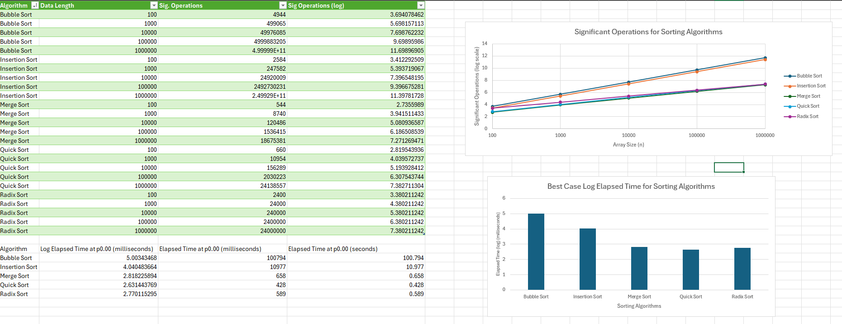
The following image contains the data table containing each algorithm’s significant operations at each data length while the graph shows the time complexity of each sorting algorithm by depicting its significant operations in logarithmic scale over its array size; additionally, that image contains the data table and the bar graph containing each algorithm’s logarithmic elapsed time. The bar graph is used to compare the best-case elapsed time for each sorting algorithm using logarithmic function on the original elapsed time from the last column of the table.
For the graph and data that tracks number of significant operations for each algorithm, the graph was a logarithmic relationship between the algorithm’s data size and the number of significant operations performed. The latter is related to the number of non-nested and nested loops used for each sorting algorithm; to support this statement, Merge Sort has the least sig. operations performed by its algorithmic complexity O (n log n) while bubble sort had the most sig. operations performed by its worst-case complexity of O (n²). The program tested with a specific benchmark showed that bubble sort takes longer to sort a large data set as opposed to Merge Sort with its linear space complexity “O(n)” and logarithmic time complexity. Merge Sort utilizes secondary storage to store its sorted array halves to make the sorting process efficient as opposed to Bubble Sort sorting two adjacent elements as n times as it can depending on the data size.
As for the graph and data involving each algorithm’s elapsed time, bubble sort had the longest time to sort a data of benchmarked array size while quick sort had the shortest time to sort a data of benchmarked array size. This proves that quick sort’s time complexity was as efficient as merge sort’s time complexity at O(n * log n) while bubble sort was the least efficient as it was tested for both number of significant operations and elapsed time. The third column of the data shows each algorithm’s elapsed time in milliseconds because using that time in seconds in logarithmic form would yield inconsistent or inaccurate results for time. From the JHN benchmark process, the sorting algorithm’s elapsed time is measured as the time per benchmark operation performed for each sorting algorithm. For Radix Sort, its elapsed time nearly equals the elapsed time of Merge Sort because it uses more memory overhead than Merge Sort while it uses a coding structure with less or equal nested and non-nested loops as Merge Sort.

Feedback
In this project, I learned how to apply my knowledge of algorithmic efficiency and algorithmic complexity by developing a code that runs each sorting algorithm tested. I also realized that a computer scientist does more than just creating programs and code; a computer scientist also analyzes how different aspects of a computer program are measured and tested to prove theories along with backing up the results with validated explanations of the behavior of programs. For example, I implemented a code that tracks the number of critical operations performed within the code section of each tested algorithm. Algorithms is not just about relating its performance to the machine; it is also tracing its layout and steps taken regardless of what type of computer and programming language is used.
Every algorithm except Radix Sort involved comparing numerical elements in an array; however, they have a unique coding layout that showcases the efficiency and logic of sorting a specific array of numbers. This project also demonstrates how each algorithm is tested with not just one set of data, but numerous data sets that are known as benchmarks. Benchmarking is a scientific process to test a computer program’s or algorithm’s performance under controlled conditions to ensure a consistent data report without putting one tested object over another. This process also made me realize that people majoring in computer science are taking projects with the scientific process to test how computer theories and assumptions are proven, which is what other sciences are about. In total, this project helped me realize what a true computer scientist can do aside from creating programs.

